2026 SPRING SOCCER



3-4 Coed

BPAR SOCCER RULES & COMMITMENT GUIDELINES
- The BPAR Spring Soccer season runs from April to May. It is imperative that coaches, players and parents commit to their scheduled games.

- A player or team may participate in other leagues or tournaments but not interfere with BPAR games. Missing BPAR games for outside events may result in forfeits or removal from the program.
- Only registered players may participate. Players are only allowed to play for the one BPAR team they were officially assigned to at the start of the season. Fill-in players, including those from other teams or age groups, are not permitted. Any violation of this rule will result in an automatic forfeit.
- Our Coaches meeting will all be done via email. Coaches will receive all important/required information pertaining to the 2026 Spring Soccer Season. This allows the process to become streamlined and allows every coach to be involved. This email group can also be used as a Q&A for all coaches.

- Coaches must check emails regularly for league updates, as it will be the main correspondence from BPAR.

- FIFA rules apply with local exceptions & points of emphasis. BPAR may adjust rules, as needed, to maintain league integrity. The rules listed below are NOT all inclusive.

GAME SCHEDULING
- If a division has an odd number of teams, teams may be required to play more than the standard seven (7) games. BPAR will strive to ensure that all teams have as equal a number of games as possible.

PLAYER AGE & ASSIGNMENT
- Playing Age is as of September 30th, 2025.

- Coaches may turn in a roster for requested players. Furthermore, players will be assigned to teams, first by the players’ residential zip code or school attended. Players may be assigned to teams not within their residential zip code or school attended to accommodate the league.

PLAYER SAFETY
- To protect the safety of all players in the program, any participant wearing a cast will prohibit them from participating in BPAR games or practices. Exceptions can be made with approval from the Youth Sports Supervisor and documented approval from a physician.

- Soft casts will be permitted if approved by officials.

- All types of jewelry or headbands (earrings, bracelets, necklaces, metal barrettes, hair beads, hair clasps etc.) or hats must be removed before the game.

- Adaptive or medical aids are approved on a case-by-case basis.
PROTESTS
There are no game protests in this league. All game official and/or BPAR staff decisions are final.

WEATHER
- Games will proceed in rain but will be canceled for lightning or any weather creating unsafe conditions.
- Weather-Interrupted Games: If a game is stopped due to severe weather after reaching halftime, it will be considered a complete game and will not be rescheduled. If the game is stopped before halftime, it will be rescheduled and resume from the point it was stopped, including quarter, possession, and score.
- BPAR officials will assess field conditions and may shorten periods, suspend, or cancel games if fields become unsafe due to heavy rain.
- Communication regarding cancellations or weather updates will be sent by email to head coaches and/or parents.
- In the case of multiple cancellations, the schedule may be adjusted (e.g., doubleheaders), but rescheduling is not guaranteed due to external factors.
- BPAR’s goal is to do our best to provide every team with the standard 7 games each season. However, we will not schedule beyond November 1st as stated in the registration, in order to respect all participants' time and previously planned commitments.
- If a rescheduled game cannot be made up by one or both teams involved, it will result in a forfeit and will not be rescheduled at a later date.

UNIFORM
- Each player must have on their BPAR issued jersey. Advertisements are not allowed. Individuals or teams are allowed to have players name on the back of the jersey.
- Age specific shin guards underneath their socks are required.
- Cleats are recommended but not required. Players may wear any color cleats, but they must be soccer-specific—NO football cleats (cleats with a front toe stud) or metal/steel cleats are allowed.
- Shorts: Any Color, No pockets, Entire team must be uniform Socks: Black, white, or team color
- Non-uniform/Under kit clothing is allowed but must match the uniform color or black.

SPORTSMANSHIP – Coaches, Players & Spectators
- Unsportsmanlike / Unbecoming Behavior
  - Unsportsmanlike behavior toward officials, coaches, players, teams, or spectators is strictly prohibited.
  - BPAR staff and officials have the authority to determine inappropriate conduct by coaches, players, teams or spectators including but not limited to intoxication, verbal abuse, taunting, profanity, or physical intimidation.
  - Offenders will be required to leave the event immediately and may face permanent bans from BPAR events.
- Game Safety & Enforcement
  - Officials may end a game if the atmosphere is unsafe or violates BPAR values.
  - Any conduct, which is deemed unsportsmanlike in the opinion of the referee, will result in a warning. Depending on the severity, the game may be stopped, and the player, coach, or spectator may be ejected from the game without a warning.
    - Ejected individuals must leave immediately.
    - The game will not continue until the ejected party has left the premises.
    - If they do not leave, the referee will forfeit the game immediately and award the win to the opposing team.
- Suspensions & Dismissals
  - If ejected, that individual would fall under suspension from BPAR and would not be allowed on any BPAR premises until reinstated by BPAR.
  - Ejected individuals may face suspensions ranging from one (1) game to the entire season.
  - If a 2nd ejection occurs, they will subject to dismissal from the BPAR league.
  - BPAR reserves the right to remove any coach, player, or spectator at any time for unsportsmanlike or unbecoming misconduct for a BPAR event.

COACHES
- Must show respect toward spectators, opponents, referees and BPAR staff.
- A maximum of three (3) coaches are allowed on the sideline during the game.
- One (1) coach per team may be on the field to provide instruction, but must remain along the sidelines - not in the middle of the field or near the goals.
- Inform parents about the consequences of inappropriate behavior towards officials.
- Are responsible for cleaning up their bench area after the game.
- BPAR-Specific Rule: Referees are assigned by BPAR. If a referee is unavailable, the game will still proceed. An assistant coach or parent will need to keep track of the game time for substitutions and end-of-quarter timing. All games must end 50 minutes after the scheduled start time to keep the schedule on track.

SPECTATORS
- Must show respect toward other spectators, players, coaches, referees and BPAR staff.
- Must sit on the opposite side of the field from players and behind the outermost line.
- Are not allowed to sit or stand behind the soccer goals.
- Anyone using inappropriate language or yelling at anyone will be required to leave the field.

REFEREES
- 3–4 division will have one referee minimum per field.
- The referee is there to ensure games start on time, notify coaches when to make substitutions/end of quarter, lead the new ball roll ins, call fouls, provide rule interpretation, assist with half time if needed, ensure fun and fair play, and collect equipment after the game.
- The referee is the final authority on the field.
- Referees have the authority to step in at any time to deescalate or resolve questions, issues, or disputes.
- Disrespectful words or behavior toward referees will not be tolerated.
- Games may be stopped, suspended, or terminated due to interference from coaches, players, or spectators.
- Referees can remove coaches, players, parents, or spectators if necessary to maintain control and a positive atmosphere.
- BPAR Specific- Rule: BPAR assigns officials; if BPAR officials are unavailable, coaches must referee the game. Games will stop 50 minutes after the scheduled start time to maintain scheduling.

3-4 Coed Basic Breakdown – 7 Game Season – No Playoffs
Age Division  (as of Sept. 2025) | # Players on Field | Goalie | Game Length*  (5 Min. Half-Time) | Offsides | Heading | Yellow/Red Cards | Ball Size | Goal Size | Field Size
3 - 4 yrs | 4 v 4 | No | 4 x 8 min quarters | No | No | No | 3 | 4’H x 6’W | 25 yds x 40 yds

SOCCER RULES

NOT ALLOWED in 3-4 & 5-6 COED
- Heading – Intentionally, hitting the ball with the forehead to control it

- Slide Tackling – a defensive move, where a player slides on the ground to take the ball from an opposing player.

- 3-4’s Hand Ball – Violations will result in a stoppage of play. Coaches must instruct players “not” to use their hands.

- Offsides – when the offense is in the opponent's half of the field and closer to the goal than the ball and the second-to-last defender.

- No Penalty Kicks or Rough Play is allowed.

- Yellow/Red Cards - a yellow card is a warning to a player, while a red card is an immediate ejection from the game.

START OF PLAY/ KICK OFF
To start a game, a quarter and after a goal, the kick-off is performed at the mid-field line by one of the offensive players.
The ball will be considered in play when it has been kicked and is moving in any direction. The defensive team must line up ten (10) yards away from the ball (outside of the circle) and cannot touch the ball until it is in play. Both teams must be in their respective halves of the field at the kick-off. The player kicking off cannot touch the ball a second time until it has touched another player.

*NEW BALL METHOD
Purpose & Overview:
- The New Ball Method is used instead of throw-ins to keep the game flowing.
- Designed to minimize downtime, maximize touches, and maintain attention and excitement for younger players.
- This method promotes fairness and development—not competitive advantage.
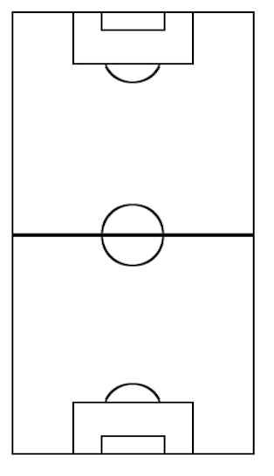
No Throw-Ins, Goal Kicks, or Corner Kicks:
- Because we are using the New Ball Method:
Baseline Out of Bounds. New ball roll in above the marked hashes.
  - There will be no throw-ins, goal kicks or corner kicks.
  - After a goal is scored, play will restart with a normal kickoff.
  - Free kicks will still be used (see Kicks section for details).
10 yards
10 yards

How It Works:
- When the ball goes completely out of bounds, the referee calls out “New Ball” and rolls a new ball onto the field.
- The ball should be rolled into a neutral space between both teams.
- The roll-in must be low and smooth—no bouncing the ball into play.
- The new ball should not favor either team or start a counterattack.
- If the ball rolls out of bounds on the baseline, the new ball roll-in will take place at the marked hash locations, which are set 10 yards from the baseline. (See diagram for reference.)
Coach Roles:
- The Referee will serve as the New Ball rollers for the entire game with coaches staying along the sideline to help collect balls rolling out of bounds.
- Head coaches should toss balls to referee when available to let them facilitate the next new ball roll in.
- Assistant coaches may assist with collecting out-of-bounds balls.

Additional Guidelines:
- This method is not intended to help a team score or gain an advantage.
- If the ball repeatedly goes out of bounds in the same corner after a couple of attempts, the Referee may call for a “Reset.”
  - Players will return to kickoff position.
  - Possession will alternate with each reset. The first reset will go to the home team (listed first on the schedule).
  - Play resumes as normal from the kickoff.
- If the ball becomes stuck in a corner or the restart situation is unclear, use the term “Reset” instead of forcing a 50/50 ball.

Helpful Resource:
- New Ball Method (Take 2) – Instructional Video (https://www.youtube.com/watch?v=g5sRbfCbOQM)
  - Note: While the video includes some differences from the guidelines above, it still provides a helpful overview of the overall concept and intent behind the New Ball Method.
SUBSTITUTIONS
- 3-4’s Player substitutions occur every four (4) minutes, and the clock will stop during these breaks.
- After a mid-quarter substitution, play resumes with a new ball roll-in to the team that had possession at the time of the substitution/stoppage.
- Substitution Area: Players waiting to enter should line up at the center line (midfield) on their team’s sideline, next to the field but not on it, and be ready to enter when the referee signals. We want to encourage players to learn how to substitute properly!

- All players must be substituted out of play if the team has enough available players to rotate the entire lineup.
- No player is allowed to play the entire game.

PLAYER PRIVILEGES
All players may play the ball with their feet, head, knees, chest, body, or shoulders.

NO GOALIE – “Goal Guarding” Rules
- Purpose: These rules are designed to teach proper field positioning and team shape. They encourage players to learn team defense, game flow, and sweeper-style positioning rather than relying on a single player to guard the goal.
- No “Goal Guarding”: Players are not allowed to stand in or near the goal to act as an informal goalkeeper.
- No Stationary Defenders: Defenders cannot remain in front of the goal solely to block shots.
- Brief Entry Only: Players may briefly enter the goal area to attempt a block but must immediately exit after the play. Defenders should stay active and engaged in open play, rather than camping in the goal box.
- No “Wall Defenders”: Teams cannot group multiple players directly in front of the goal to block shots. This helps prevent games from turning into a defensive stalemate where scoring becomes nearly impossible.
- Keep Defenders Active: Players are encouraged to defend by moving, pressuring the ball, and challenging attackers—not standing still in the goal box.
- Coaches and referees will need to remind players to move if they linger in the goal area too long.

SCORING
- A ball that is kicked between, but not over the goalposts at the opponent’s goal line, is considered a score equal to one (1) point. The ball must be completely over the entire goal line to be considered a goal. The ball does not have to touch the net to be considered a goal.
- Goals can be scored anywhere on the field. Goals may not be scored directly from a free kick.

KICKS
- All opposing players must be at least five (5) yards from the ball on all free kicks. Player kicking the ball is not allowed to touch the ball again until another player touches it.

FOULS & MISCONDUCT
- All Fouls (tripping, pushing, etc.) result in a free kick taken from the point of the foul.

Optional Halftime Drill – 3-4s: “Shoot & Shine”
- Purpose:
To introduce players to proper penalty kick (PK) setup, encouraging skill development and make learning fun. This drill also gives players something to work toward and look forward to each week.
- Overview:
  - This drill takes place during halftime of each game.
  - Goals scored during this activity do not count toward the game score.

- Setup:
  - At halftime, each team goes to the goal they will defend in the second half.
  - Players form a single-file line behind the PK spot (penalty kick mark).

- How to Play:
    - Each player gets one shot to kick the ball into the goal.
    - If a player successfully scores, they are encouraged to show off their best celebration.
  - Players who do not score still get a chance to try again at the next game’s halftime—encouraging growth and persistence.

- Additional Notes:
  - Coaches are encouraged to practice this drill during team practices so players are familiar with it.
  - Parents are welcome to help rebound balls to keep the drill moving quickly and smoothly.
  - The image below illustrates the setup, except for the of cone in the middle. Players will have a completely open goal to shoot at.
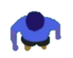
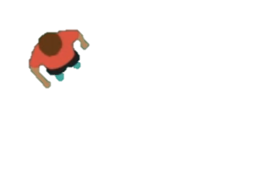

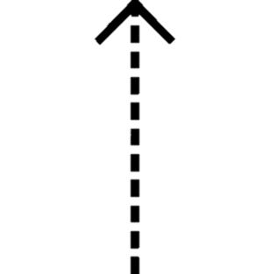
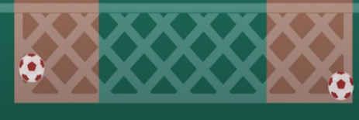

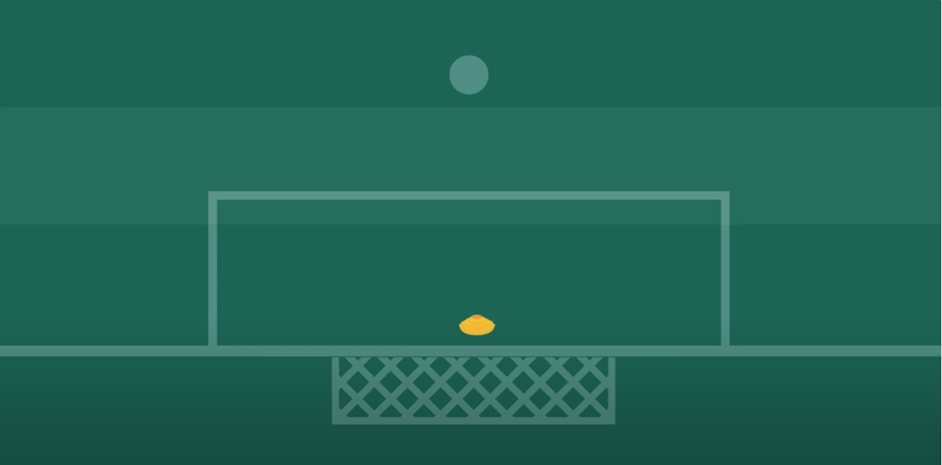
Parents Rebounding
Coach Leading
Players in Line

